**CTF Challenge: Sniffing**

**What is Sniffing?**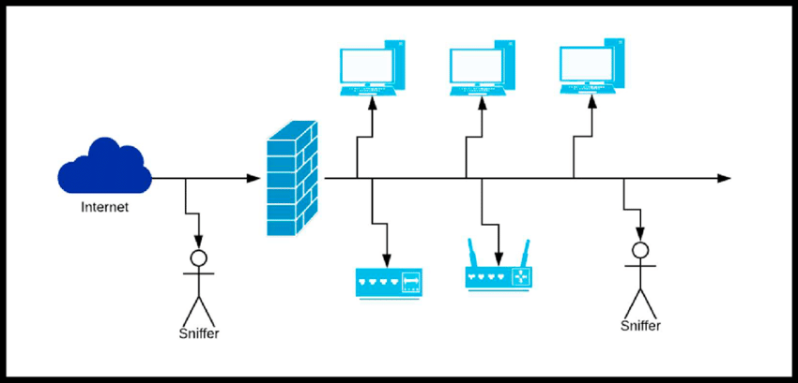

"Sniffing" typically refers to a form of network analysis or eavesdropping where a device or software application captures and monitors data packets traveling across a network. Here are some key points about sniffing:

### **Types of Sniffing**

1. **Passive Sniffing**: Monitors and captures data packets without altering them. It’s typically used on networks where the traffic is broadcasted to all devices, such as those using a hub.
2. **Active Sniffing**: Involves injecting traffic into the network to induce packets to be sent, which can then be captured. This method is often used in switched networks to direct traffic to the sniffer.

### **Tools for Sniffing**

* **Wireshark**: One of the most popular and powerful network protocol analyzers.
* **tcpdump**: A command-line packet analyzer.
* **Cain & Abel**: A versatile password recovery tool for Microsoft OS that can also perform network sniffing.
* **Ettercap**: A comprehensive suite for man-in-the-middle attacks on LAN.

### **Use Cases**

* **Network Troubleshooting**: Identifying network bottlenecks, packet loss, or misconfigurations.
* **Security Analysis**: Detecting unauthorized access or malicious activity.
* **Performance Monitoring**: Analyzing network traffic patterns to optimize performance.
* **Forensic Analysis**: Investigating network security breaches.



# **Capture the Flag (CTF) Challenges**

Flag 1. Which tool is known as a powerful network protocol analyzer?

Answer: Wireshark

Flag Captured

Flag 2. What type of sniffing monitors and captures data packets without altering them?

Answer: Passive

Flag Captured

Flag 3. Which sniffing tool is also a versatile password recovery tool for Microsoft OS?

Answer: Cain & Abel

Flag Captured

Flag 4. What network device broadcasts data to all devices?

Answer: Hub

Flag Captured

Flag 5. What method of sniffing involves injecting traffic into the network to induce packets to be sent?

Answer: Active

Flag Captured